Ultrasonic Distance and Compass Reader

I had previously developed a little project which used an ultrasonic distance sensor and a clever little library called ‘talkie’. This project measured the distance in front of the sensor and then read it out- the sort of thing that could be used to help a visually impaired person navigate. Now I’ve included the Duinotech XC4496 compass module, so that the Reader can read out compass bearing and distance.

The parts list is very similar to the previous project:

1 x XC4410 Duinotech Uno Board

1 x XC4442 Arduino compatible ultrasonic sensor

1 x WC6028 Plug to Socket Jumper Lead 40 pack

1 x XC4496 Magnetic Compass Module

1 x PS0134 Stereo Line socket

1 x RR0552 150R resistor pack

1 x AA2090 Stereo Headphones (if you don’t have headphones)

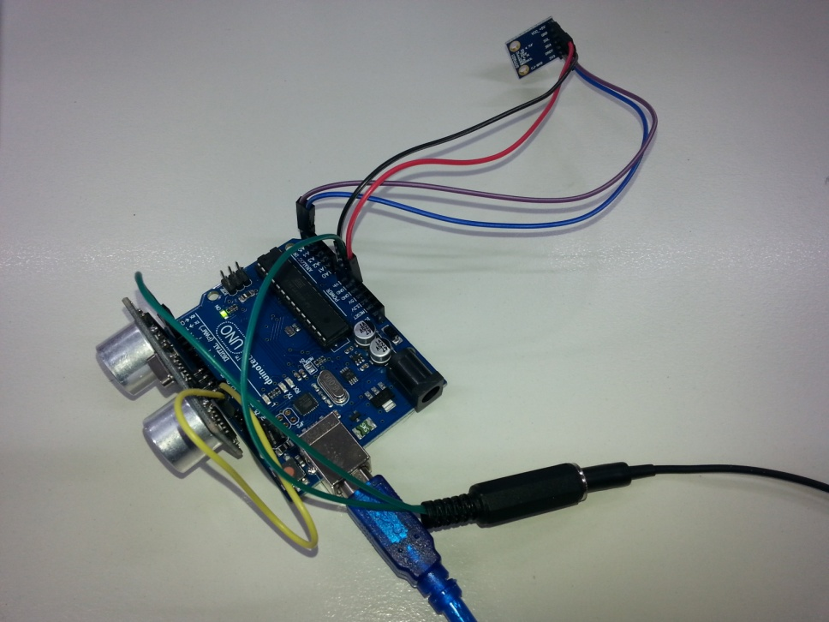

### Connections:

I’ve shuffle some of the connections from the previous project, mostly because we’re running out of 5V and GND connections. There is some soldering to create a headphone socket- if you don’t want to solder, you can substitute a Piezo speaker (eg AB3440). Just push the bare ends of the wires into the headers on the Uno.

To put together the headphone socket, cut the plug end off two of jumper leads, and bare back the wires. Solder one end of the resistor to the small tabs at the end of the socket, and then solder one of the jumper leads to the other end of the resistor, and the other jumper lead to the large tab in the socket. The result should be as follows:

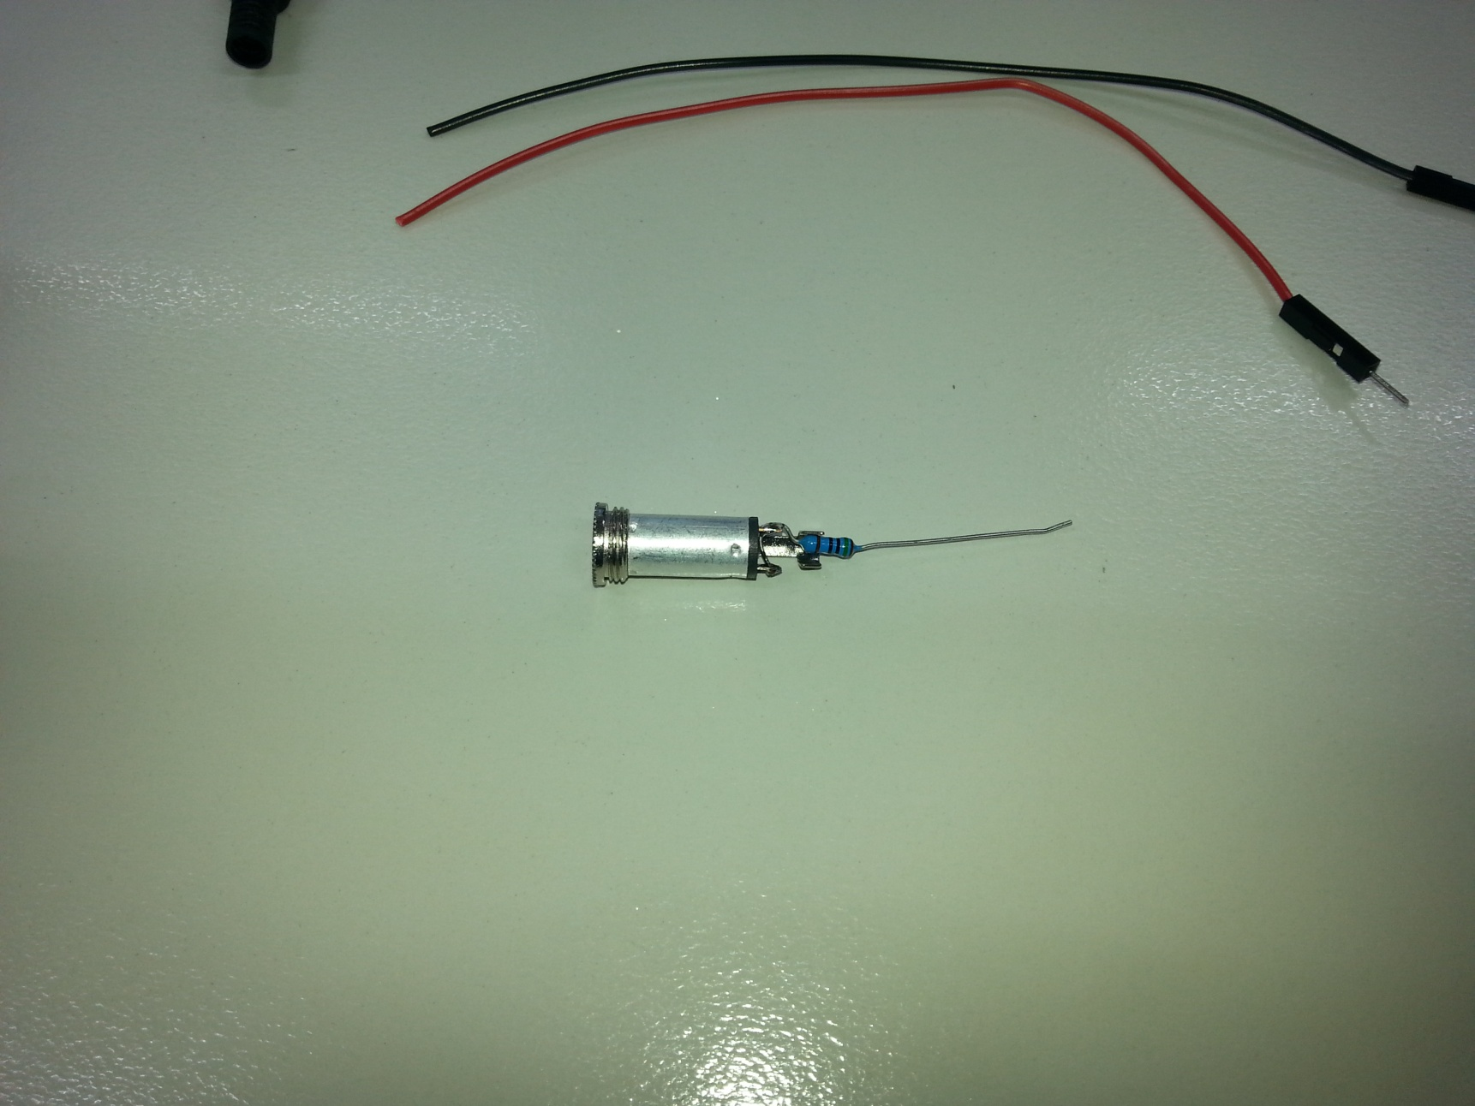 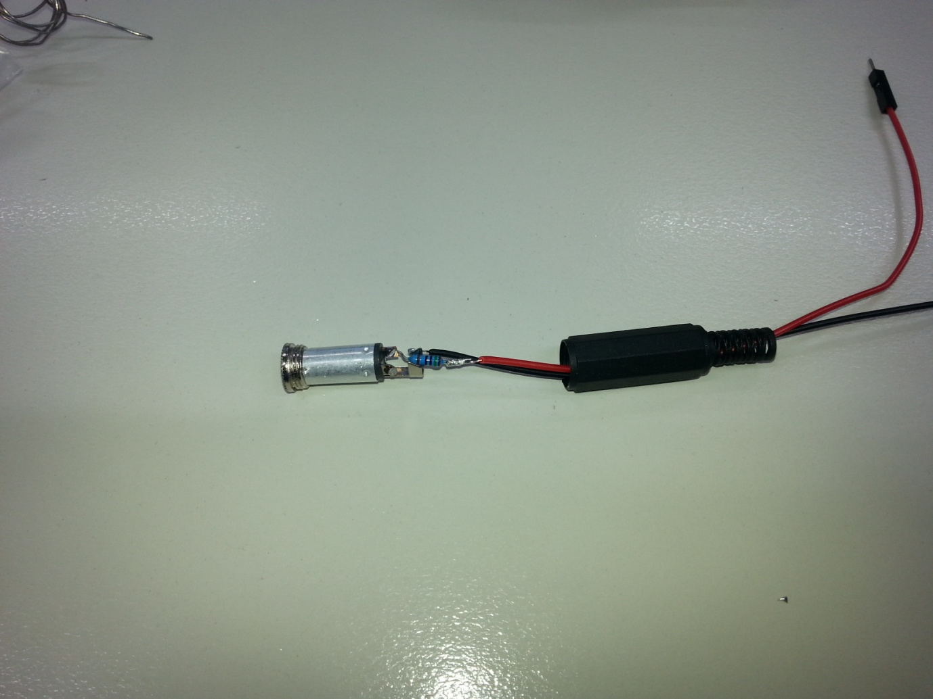

|  |  |  |  |  |
| --- | --- | --- | --- | --- |
| Uno | Headphone Socket | Ultrasonic Sensor | Compass Module | Function |
| 5V |  |  | VCC_+5V | Power |
| GND | Black |  | GND | Ground |
| A4 |  |  | SDA | I2C Data |
| A5 |  |  | SCL | I2C Clock |
| D3 | Red |  |  | Audio from Arduino |
| D8 |  | VCC |  | Digital Pin set high for 5V |
| D9 |  | ECHO |  | Echo response for ultrasonic module |
| D10 |  | TRIG |  | Trigger for ultrasonic module |
| D11 |  | GND |  | Digital pin set low for GND |
| D13 |  |  |  | Switch- connect to GND to run |

I’ve also used another trick that will save a GND and 5V pin, and plugged the ultrasonic sensor straight into D8-D11. The sketch sets D8 high and D11 low so that the sensor gets power through the pins. You could break these out on jumper leads if necessary. You’ll also need to connect something to D13 to activate the switch- either run some leads out to a pushbutton, or juts bridge D13 to GND with a jumper lead to let it run continuously. A neat way to do this if you want it permanently talking is to jumper D13 to GND with a small offcut of resistor leg.

### Code:

Like the previous version, you will need ‘talkie’ library, downloadable from <https://github.com/going-digital/Talkie>, or check out the version included here, as it has been modified to work with more recent Arduino versions. The compass sensor also uses the Wire and math libraries, but these are included with the Arduino IDE. Note that this will only work on an UNO. Compile and upload the sketch, and plug headphones into the socket, and you should get a compass bearing and distance read out. If you only get distance, then there is a problem with the compass sensor- check the wiring. The compass reading is based on the direction the X arrow is pointing on the compass module.

### Improvements:

I tracked down a sound sample for ‘metres’, so this version reads in metres. The compass sensor will only accurately read bearings if it is mounted horizontally, so what this project probably needs next is a way to mount all the components so that they can read accurately in your chosen application. The Uno can of course be run from a 5V USB source, such as a portable phone charger pack, but anything up to about 12V can be fed into the VIN pin- a 9V battery would make a compact power source. You could also run an AUX cord to an amplified speaker if you need louder sound.

The ‘talkie’ library has heaps of other sound samples, so this project could be added to even further if extra sensors were added.